**Lab 1: Successfully Created Key Pair for EC2 – done**

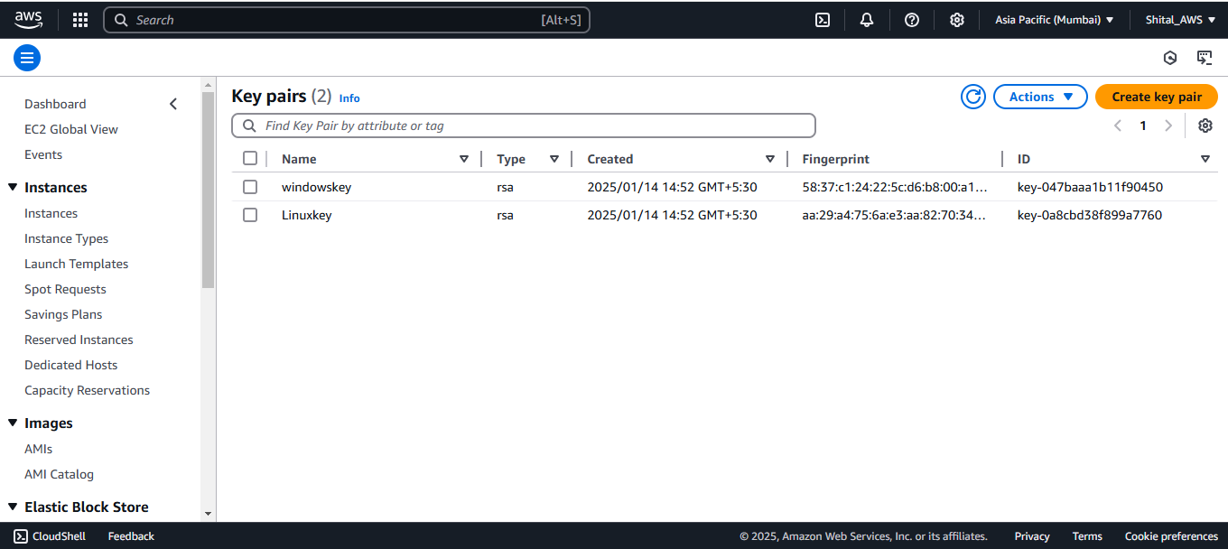

**Lab 2: Successfully Created Security Group – done**

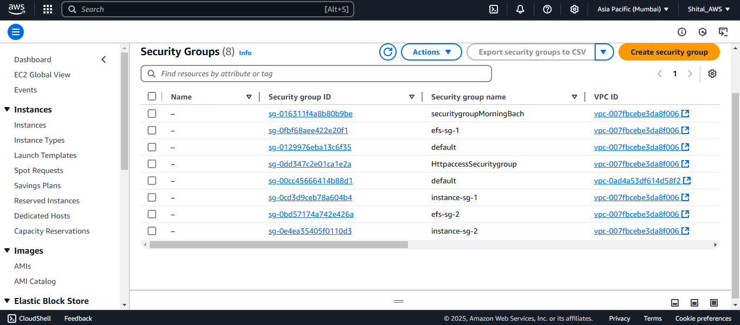

**Lab 3: Successfully Provision a Windows VM and access it.**

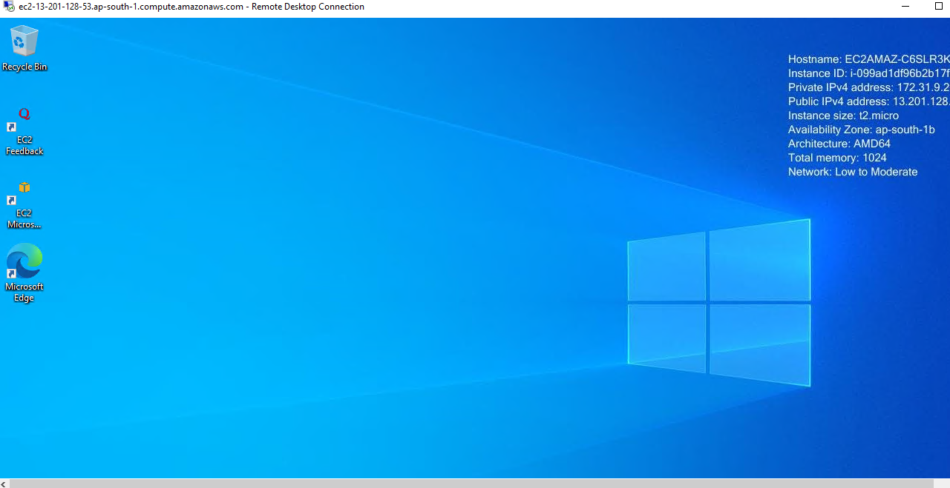

**Lab 4: Successfully done the lab of Provision a Linux VM and access it. - done** 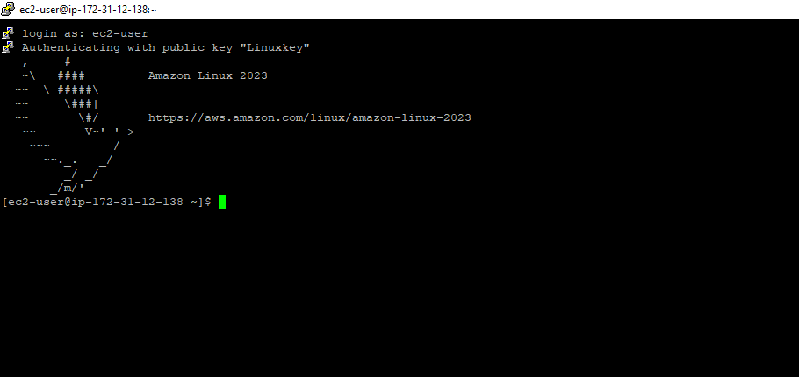

**Lab 5:** **Successfully done the lab of Playing with Security Group.**

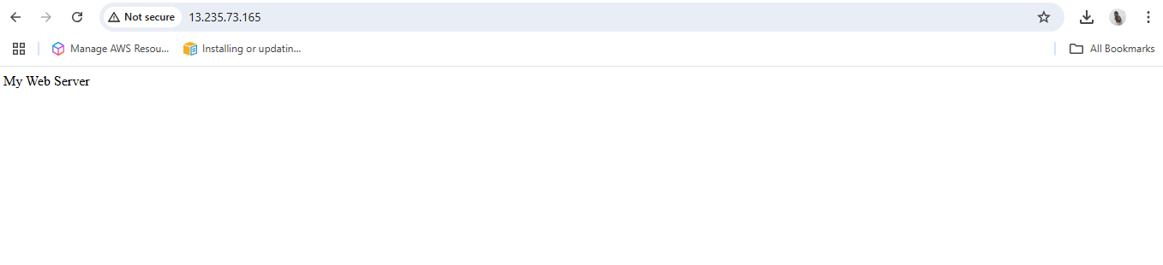

**Lab 6: Successfully done the lab of Linux VM provision with custom script or User data**

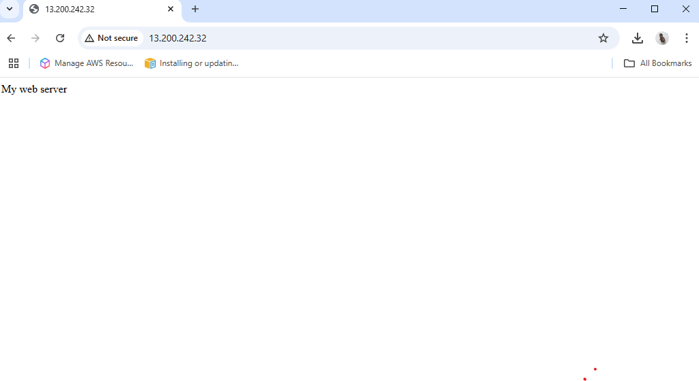

**Lab 7: Successfully done the lab of Application Load Balancer (Round Robin algorithm) – done**

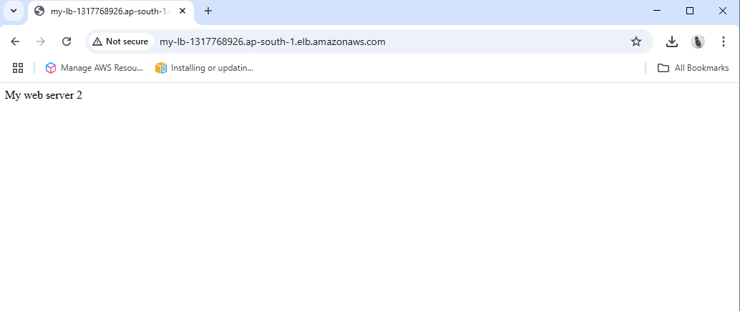

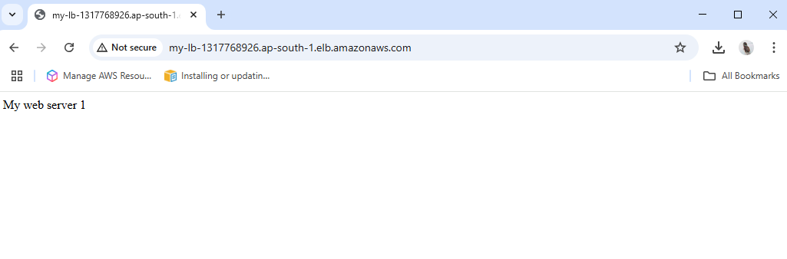

**Lab 8-** **Successfully done the lab of Application load balancer (content base routing with linux server)- done**

**First rule:-**

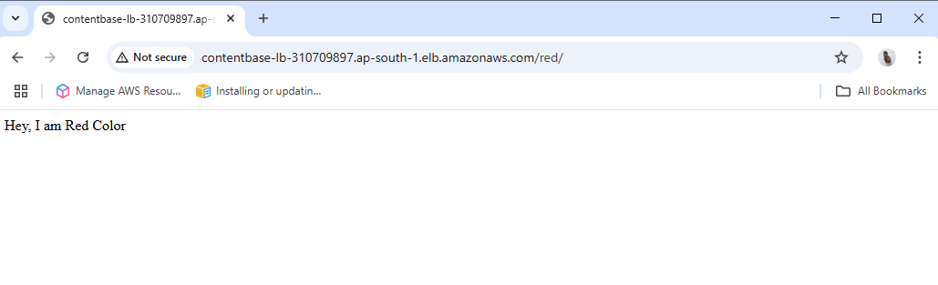

**Second Rule:-**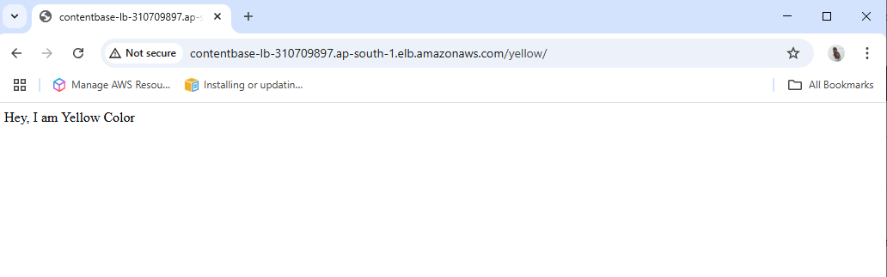

**Default rule:-**

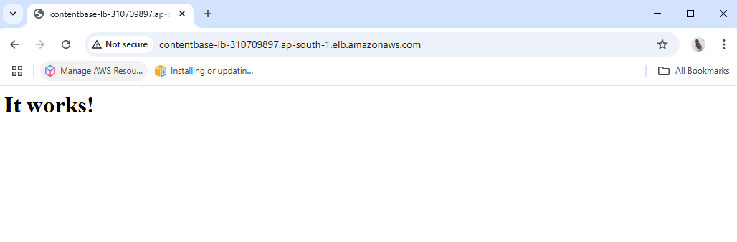

**Lab 9: Successfully done the lab of EC2 Auto scaling**

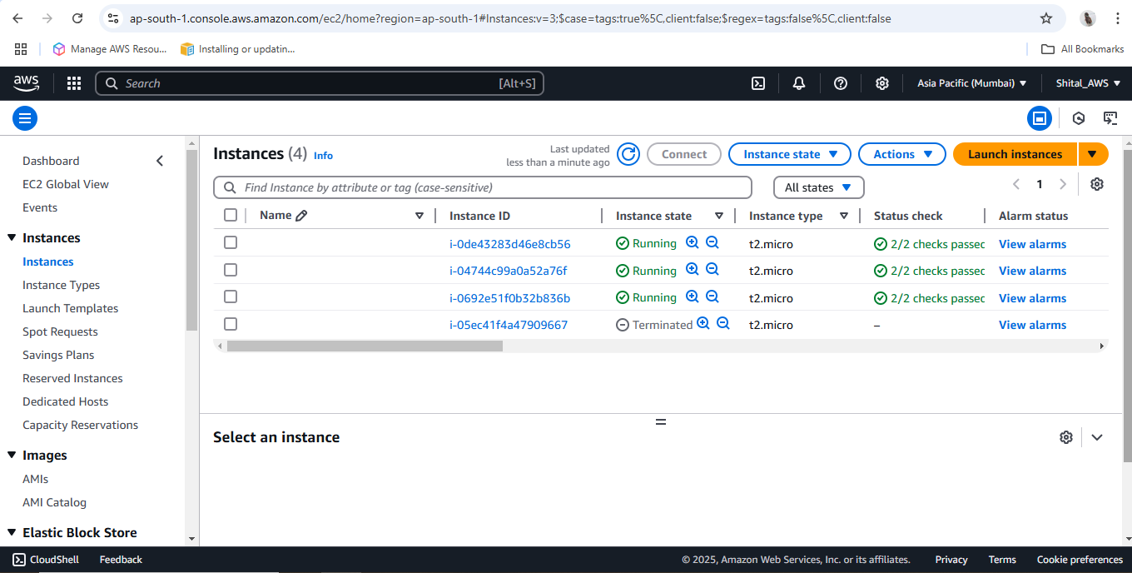

**Autoscaling group -**

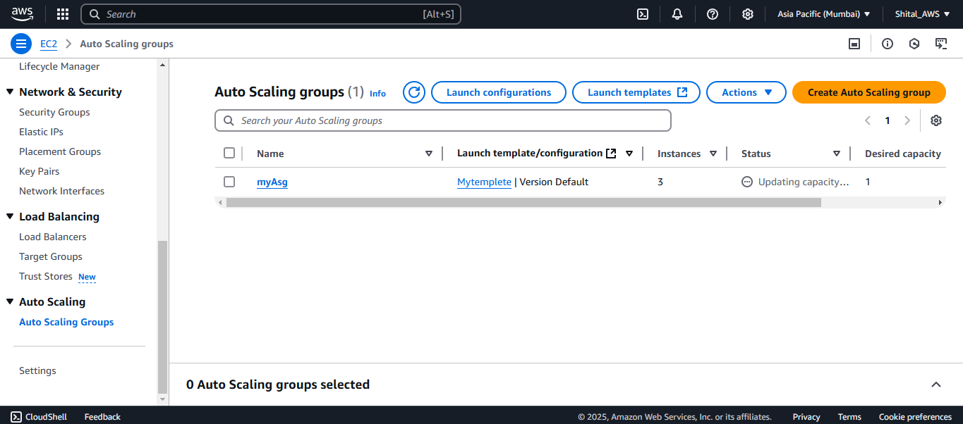

**Lab 10: Successfully done the lab of Elastic IP, Private IP and Public IP**

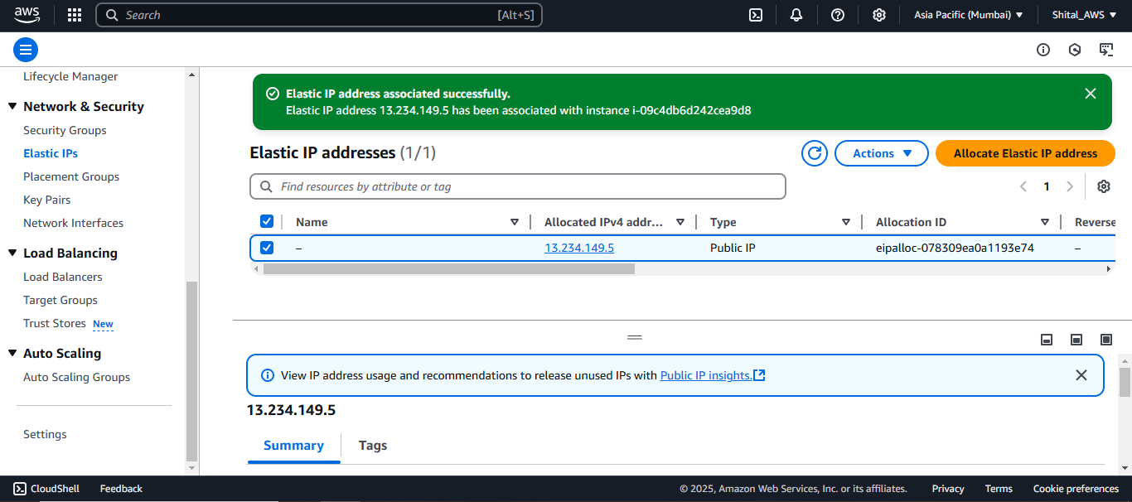**Assigned elastic Ip to ec2**

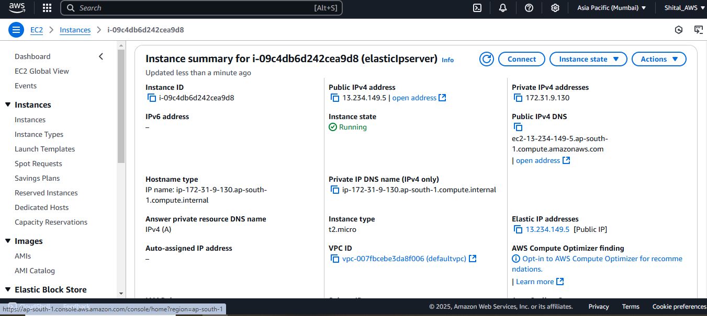

**Lab 11: Successfully done the lab of AWS AMI**

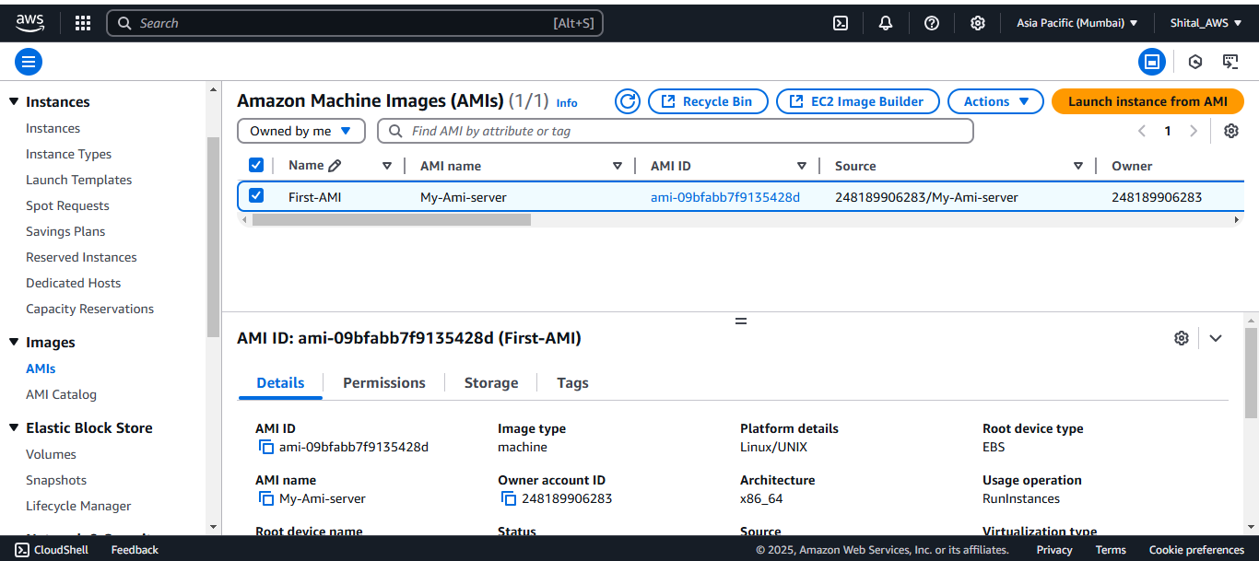

**Lab 12: Successfully done the lab of AWS Snapshot**

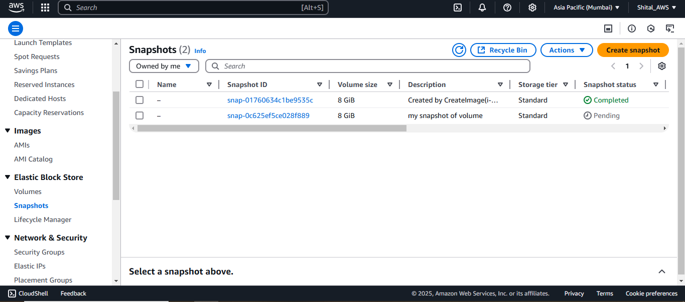

**Lab 14: Successfully done the lab of Accessing S3 data into Instance with Role**

